AT 121 – Chapter 4 - Lab 3 – Ohms Law – Part 2

Name :__________________________________

Date: ___________________________________

1. What would happen if a 10A fuse were in place of a 20A Fuse?

A. The fuse would blow
B. The circuit would be damaged
C. The component that the fuse is protecting would be damaged
D. Choice B and C

2. What would happen if a 20A fuse were in place of a 10A Fuse?

A. The fuse would blow
B. The circuit would be damaged
C. The component that the fuse is protecting would be damaged
D. Choice B and C

3. Find the current flow in the circuit to the right;

If “X” Ohms were =
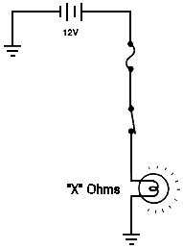

1 Ohm = ___________________

2 Ohms = __________________

4 Ohms = __________________

10 Ohms = _________________

50 Ohms = _________________

100 Ohms = ________________

4. A technician is installing a 55-Watt driving lamp. The vehicles electrical system drops to 12 volts, what is a good rating for a fuse the technician should use to protect this circuit?

A. 2 Amps
B. 3.5 Amps
C. 5 Amps
D. 10 Amps

5. Find the current flow in the circuit to the right;
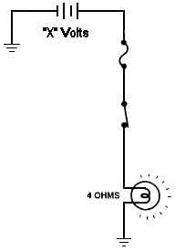
If “X” Volts were =

1 Volt = ___________________

2 Volts = __________________

4 Volts = __________________

10 Volts = _________________

50 Volts = _________________

100 Volts = ________________

6. If you had an outlet that was 120 Volts, and could handle a maximum current of 15 A, how many 60 Watt bulbs could be placed on that circuit? (Hint, find out how much 1 bulb draws in current first.. then solve..)

A. 3
B. 9
C. 15
D. 30

7. Find the voltage in the circuit to the right;

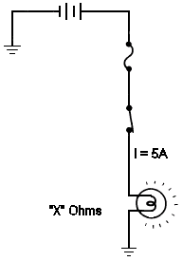
If “X” Ohms were =

1 Ohm = ___________________

2 Ohms = __________________

4 Ohms = __________________

10 Ohms = _________________

50 Ohms = _________________

100 Ohms = ________________

8. If corroded switch terminals caused abnormal, increased resistance at a switch, the total current flow
in a circuit would...

A. Increase or decrease, depending on the amount of resistance increase
B. Increase
C. Decrease
D. Stay the same

9. If shorted switch terminals caused abnormal, decreased resistance at a switch, the total current flow
in a circuit would...

A. Increase or decrease, depending on the amount of resistance increase
B. Increase
C. Decrease
D. Stays the same

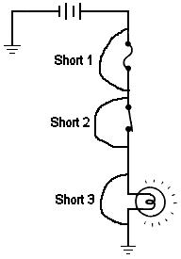10. In the picture to the right, Short 1 would; (assume Short 1 is only short)

A. Cause the bulb to blow out
B. Keep the bulb on at all times
C. Bypass the fuse
D. Cause the fuse to blow

11. In the picture to the right, Short 2 would; (assume Short 2 is only short)

A. Cause the bulb to blow out
B. Keep the bulb on at all times
C. Bypass the fuse
D. Cause the fuse to blow

12. In the picture to the right, Short 3 would; (assume Short 3 is only short)

A. Cause the bulb to blow out
B. Keep the bulb on at all times
C. Bypass the fuse
D. Cause the fuse to blow

13. The circuit to the right shows:

A. A Series Circuit
B. A Parallel Circuit
C. An open Circuit
D. A Series Parallel Circuit

14. Find the total resistance in the circuit to the right;

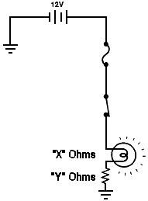If “X” Ohms were and If “Y” Ohms were =

A. 1 Ohm 7 Ohms = ________________________

B. 2 Ohms 3 Ohms = ________________________

C. 4 Ohms 40 Ohms = _______________________

D. 10 Ohms 3 Ohms = ________________________

E. 50 Ohms 90 Ohms = _______________________

F. 100 Ohms 8 Ohms = ________________________

15. Given the above values, find the total current flow

A. __________________ B. ____________________ C. ____________________

D. __________________ E. ____________________ F. _____________________

16. If voltage drop had to be described, which statement best describes it?

A. The sum of all voltage drops must equal the source voltage.
B. The sum of the voltage times the current equals the source voltage.

17. Find the voltage drop of the following components in the circuit to the right;
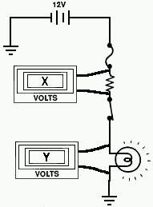
Find the voltage drop of “X” if “Y” is;

Y = 3 Volts ------ X = __________________

Y = 1 Volts ------ X = __________________

Y = 6 Volts ------ X = __________________

Y = 11 Volts ------ X = __________________

Y = 4 Volts ------- X = _________________

18. The circuit to the right shows:

A. A Series Circuit
B. A Parallel Circuit
C. An open Circuit
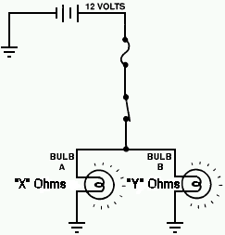
D. A Series Parallel Circuit

19. Find the total resistance in the circuit to the right;

If “X” Ohms were and If “Y” Ohms were =

A. 1 Ohm 7 Ohms = ________________________

B. 2 Ohms 3 Ohms = ________________________

C. 4 Ohms 40 Ohms = _______________________

D. 10 Ohms 3 Ohms = ________________________

E. 50 Ohms 90 Ohms = _______________________

F. 100 Ohms 8 Ohms = ________________________

20. Given the above values, find the total current flow

A. __________________ B. ____________________ C. ____________________

D. __________________ E. ____________________ F. ____________________

22. A technician is installing a sub woofer in a vehicle. The vehicle's amplifier requires a 4-ohm sub. The sub that the technician must install is 8 ohms. How can the technician use their knowledge of series and parallel circuits to make this work? What resistors would be needed, and how could the system be wired to make the vehicle win the big stereo contest?

