AT 121 – CH 4 - Lab 1 – Ohms Law.
TIP - DRAW THE OHMS LAW CIRCLE HERE!!!
Name :__________________________________

Date: ___________________________________

Natef Task - VI. ELECTRICAL/ELECTRONIC SYSTEMS

5. Diagnose electrical/electronic integrity of series, parallel and series-parallel circuits using principles of electricity (Ohm’s Law). P-1

1. Ohm's Law states that...

A. Voltage = Current x Resistance
B. Voltage = Resistance / Current
C. Current = Voltage x Resistance
D. Resistance = Current x Voltage

2. In an electrical circuit, if the voltage stays the same, but the resistance increases, the current will...

A. Increase
B. Increase or decrease, depending on the amount the resistance goes up
C. Decrease
D. Stay the same

3. To find the amount of Watts in a circuit you would;
TIP - DRAW THE WATTS LAW CIRCLE HERE!!!
A. Watts = Volts x Current
B. Watts =Voltage x Resistance
C. Watts =Current x Resistance
D. Watts = Volts / Current

4. What would happen if a 15 fuse were in place of a 20A Fuse?

A. The fuse would blow
B. The circuit would be damaged
C. The component that the fuse is protecting would be damaged
D. Choice B and C

5. What would happen if a 10 fuse were in place of a 5 Fuse?

A. The fuse would blow
B. The circuit would be damaged
C. The component that the fuse is protecting would be damaged
D. Choice B and C

6. Find the current flow in the circuit to the right;

If “X” Ohms were =
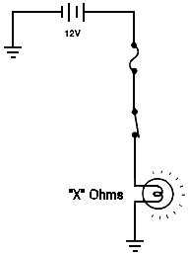

2 Ohm = ___________________

3 Ohms = __________________

5 Ohms = __________________

90 Ohms = _________________

70 Ohms = _________________

99 Ohms = ________________

7. A technician is installing a 100-Watt driving lamp. The vehicles electrical system peaks at 15 volts, what is a good rating for a fuse the technician should use to protect this circuit?

A. 2 Amps
B. 3.5 Amps
C. 5 Amps
D. 10 Amps

8. Find the current flow in the circuit to the right;
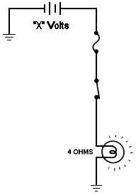
If “X” Volts were =

10 Volt = ___________________

12 Volts = __________________

14 Volts = __________________

15 Volts = _________________

16 Volts = _________________

99 Volts = ________________

9. If you had an outlet that was 240 Volts, and could handle a maximum current of 15 A, how many 60 Watt bulbs could be placed on that circuit?

A. 30
B. more than 90
C. less than 15
D. more than 30

10. Find the voltage in the circuit to the right;

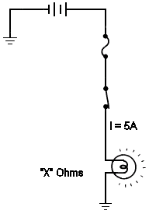
If “X” Ohms were =

10 Ohms = ___________________

12 Ohms = __________________

14 Ohms = __________________

15 Ohms = _________________

16 Ohms = _________________

99 Ohms = ________________

