The Measurement of Current and Voltage

Current is measured with an ammeter. To measure the current through a circuit element the ammeter must be connected in series with the circuit element. To minimize it affects on the circuit being analyzed, the ammeter must have a small internal resistance. (Why?)

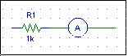

Ammeter in series with a resistor. The ammeter reads the current passing through the resistor.

Potential differences (voltage differences, voltage drops or simply voltages) are measured with a voltmeter. To measure the potential difference across a circuit element the voltmeter must be connected in parallel with the circuit element. To minimize its affects on the circuit being analyzed, the voltmeter must have a large internal resistance. (Why?)

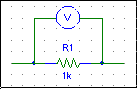

Voltmeter in parallel with a resistor. The voltmeter reads the potential difference across the terminals of the resistor.

