Resistors Connected in Series and in Parallel

In the last lecture we showed that if two resistors R₁ and R₂ are connected in series the equivalent resistance is given by

R = R₁ + R₂.

This formula is easily extended to the case where three, four or more resistors are connected in series.

A set of resistors are connected in series if and only if the current through each resistor is the same. This is possible only if one resistor follows another in a connection sequence.
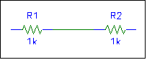

Resistors R1 and R2 are connected in series.
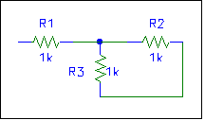
Resistors R1 and R2 are not connected in series. (Why?)
Are resistors R2 and R3 connected in series? How can you tell?

Example

Resistor R₁ = 12.0 ohms and R₂ = 8.00 ohms are connected in series across an ideal dry cell battery. (An ideal battery has no internal resistance.) A voltmeter measures a 7.50 volt potential drop across R1.
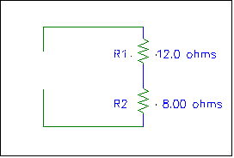
- What is the current in the circuit?

- What is the voltage of the battery?

The equivalent resistance of the resistors is R = 20 ohms.
The current I through R₁ is also the current through the battery:

V = 12.5 volts
- (Alternative solution to b.) The potential drop (or voltage or voltage drop) across R₂ is
(The same answer as before.)

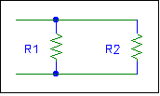Parallel Wiring

The figure at the right shows resistors R1 and R2 connected in parallel.

A set of resistors is connected in parallel if and only if the voltage across each resistor is the same.

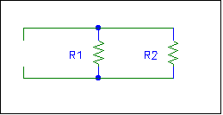
If a battery with voltage V is placed across resistors connected in parallel, the battery “sees” a single equivalent resistance R placed across its terminals. To find this equivalent resistance note we need Kirchhoff’s junction rule:
V
I₁
I₂
I

The total current entering a junction equals the total current leaving that junction.

Thus and This formula is easily extended to the case of three or more resistors connected in parallel.

Example

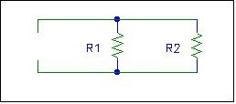
The 12.0 ohm and 8.00 ohm resistors of the previous example are connected in parallel across the same ideal dry cell battery.

- What is the current drawn from the battery?
First find the equivalent resistance R.

- Find the current through each resistor.

Equivalent Resistance of More Complicated Networks

How are resistances R2 and R3 connected in the resistance network shown at the right? They are not connected in series, because the current through R2 is not necessarily the current through R3 (why?)
•
a

b
R2 and R3 are connected in parallel because the potential drop across R3 is the same as the potential drop across R2. (Note that we can go from the top node to the bottom node in two ways: the first way is to just cross R3; the second is to just cross R2. Hence the potential drop across R3 must be the same as that across R2.)

Let R1 = R₁ = 2.0 Ω, R2 = R₂ = 3.0 Ω, R3 = R₃ = 6.0 Ω.

First find the equivalent resistance of R2 and R3:
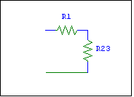
a

b

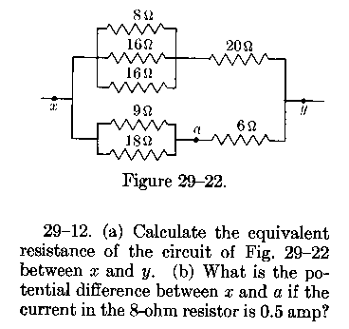

Here is an example from another textbook. Can you do this problem?

Here are the answers: (a) 8.0 ohms, (b) 12 volts.
Internal Resistance

All real seats of emf have an internal resistance. If no current is drawn from the seat of emf, the internal resistance has no effect. When the seat of emf is connected to a circuit and current is drawn from it, the potential difference across its terminals is less than when no current is drawn from it. The actual voltage between the terminals of a seat of emf is called the terminal voltage. A hypothetical seat of emf with zero internal resistance is called an ideal seat of emf.
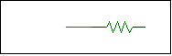
r
E
A real seat of emf can be thought of as an ideal seat of emf connected in series with an internal resistance r. E is the emf when no current is drawn. When a current I is drawn there is a potential drop Ir across the internal resistance. The terminal voltage of the seat of emf is then

Example

A 3.00 ohm resistor is connected to a 12.0 volt battery with an internal resistance of 0.200 ohms.

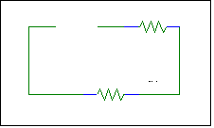
- How much current is drawn from the battery?
E
r
3.0 Ω

The equivalent resistance of the circuit is

R = 3.00 Ω + 0.200 Ω; R = 3.20 Ω.

The current drawn from the seat of emf is then

- What is the terminal voltage of the battery?

In general, the more current that is drawn from a seat of emf the lower its terminal voltage due to its internal resistance.

