Mutual Inductance

Suppose we hook up an AC generator to a solenoid so that the wire in the solenoid carries AC. Call this solenoid the primary coil. Next place a second solenoid connected to an AC voltmeter near the primary coil so that it is coaxial with the primary coil. Call this second solenoid the secondary coil. See the figure at the right.
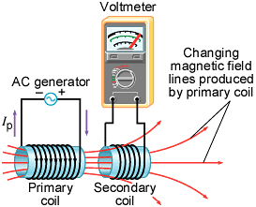

The alternating current in the primary coil produces an alternating magnetic field whose lines of flux link the secondary coil (like thread passing through the eye of a needle). Hence the secondary coil encloses a changing magnetic field. By Faraday’s law of induction this changing magnetic flux induces an emf in the secondary coil. This effect in which changing current in one circuit induces an emf in another circuit is called mutual induction.

Let the primary coil have N₁ turns and the secondary coil have N₂ turns. Assume that the same amount of magnetic flux Φ₂ from the primary coil links each turn of the secondary coil. The net flux linking the secondary coil is then N₂Φ₂. This net flux is proportional to the magnetic field, which, in turn, is proportional to the current I₁ in the primary coil. Thus we can write N₂Φ₂ ∝ I₁. This proportionality can be turned into an equation by introducing a constant. Call this constant M, the mutual inductance of the two coils:

the unit of inductance is named after Joseph Henry.
The emf induced in the secondary coil may now be calculated using Faraday’s law:

The above formula is the emf due to mutual induction.

Example

The apparatus used in Experiment EM-11B consists of two coaxial solenoids. A solenoid is essentially just a coil of wire. For a long, tightly-wound solenoid of n turns per unit length carrying current I the magnetic field over its cross-section is nearly constant and given by. Assume that the two solenoids have the same cross-sectional area A. Find a formula for the mutual inductance of the solenoids.

Self-Inductance

A current-carrying coil produces a magnetic field that links its own turns. If the current in the coil changes the amount of magnetic flux linking the coil changes and, by Faraday’s law, an emf is produced in the coil. This emf is called a self-induced emf.

Let the coil have N turns. Assume that the same amount of magnetic flux Φ links each turn of the coil. The net flux linking the coil is then NΦ. This net flux is proportional to the magnetic field, which, in turn, is proportional to the current I in the coil. Thus we can write NΦ ∝ I. This proportionality can be turned into an equation by introducing a constant. Call this constant L, the self-inductance (or simply inductance) of the coil:

As with mutual inductance, the unit of self-inductance is the henry.

The self-induced emf can now be calculated using Faraday’s law:

The above formula is the emf due to self-induction.

Example

Find the formula for the self-inductance of a solenoid of N turns, length l, and cross-sectional area A.

Assume that the solenoid carries a current I. Then the magnetic flux in the solenoid is

Transformers
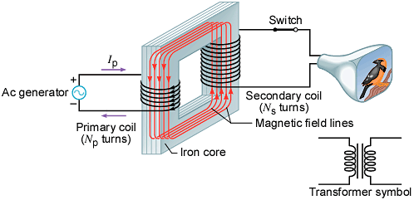
A transformer is a device for increasing or decreasing an AC voltage. It consists of an iron core with two coil wrappings: a primary coil with N_{p} turns and a secondary coil with N_{s} turns. See the figure at the right.

Assume an AC source, such as an AC generator, produces an alternating current I_{p} in the primary coil. The primary coil creates a changing magnetic flux Φ in the core which links the turns of both the primary and secondary coils. In the secondary coil the induced emf arises from mutual induction and is given by Faraday’s law as

In the primary coil the induced emf is due to self-induction and is given by Faraday’s law as

The term ΔΦ/Δt is the same in both equations since the same amount of magnetic flux Φ passes through both coils. Dividing the equations gives

If the resistances of the coils are negligible the terminal voltages V_{s} and V_{p} of the coils are nearly equal to the magnitudes of the emfs E_{s} and E_{p}. Hence we can write

This is called the transformer equation.

The power delivered to an ideal transformer on its primary circuit will match the power output on its secondary circuit and we can write I_{p}V_{p} = I_{s}V_{s} or

The details of the operation of a transformer, which also involve the magnetization and demagnetization of the iron core, is complex. Here we assume, for simplicity, a transformer operating in steady-state with a purely resistive load.
Here we neglect the resistances of the windings and the energy expended in magnetizing and demagnetizing the iron core.

