Kirchhoff’s Rules

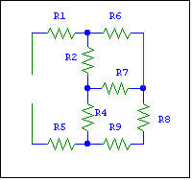
In general, complex circuits cannot be analyzed in terms of series and parallel connections. The resistance network shown on the left, for example, cannot be reduced to series and parallel connections. There is no simple way to calculate the equivalent resistance of the network.

Two rules, known as Kirchhoff’s Rules, are used to analyze circuits such as this. These rules are called the junction rule and the loop rule. We already discussed the junction rule in connection with resistors connected in parallel.

Junction Rule. The sum of the magnitudes of the currents entering a junction equals the sum of the magnitudes of the currents leaving the junction.

Loop Rule. Around any closed loop the sum of the potential rises equals the sum of the potential drops.

Loop Rule (Alternative statement) The algebraic sum of the potential rises around a closed loop equals zero.

The term “algebraic” in the last statement above simply means that signs are used to distinguish potential rises from potential drops: a potential rise is positive while a potential drop is considered to be a negative potential rise.

Kirchhoff’s Rules are named after their developer Gustav Kirchhoff (1824 – 1887). Kirchhoff (together with Bunsen) also helped develop the science of spectroscopic analysis.

Example
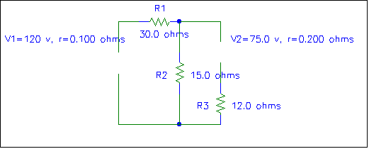
I₁
I₃
I₂
Loop 1 Loop 2
From the junction rule

I₁ = I₂ + I₃

From the loop rule applied to loop 1:

Potential drops = Potential rises.

$I_{1}\left(\text{30}\text{.}1Ω\right)+I_{2}\left(\text{15}\text{.}0Ω\right)=\text{120}\text{ V}$From the loop rule applied to loop 2: Potential drops = Potential rises

$\text{75}\text{.}0\text{ V}+I_{3}\left(\text{12}\text{.}2Ω\right)=I_{2}\left(\text{15}\text{.}0Ω\right)$
From the junction rule . Thus

Multiplying the above equations out and combining and rearranging terms gives

The negative answer for I₃ indicates that this current flows opposite to the direction chosen for it.

