Interference of Light

In the previous chapter we were able to trace the paths of light using ray optics (or geometric optics). Ray optics is valid provided that the wavelength of light is small compared to the objects the light encounters in an optical system. In this chapter we consider what happens to light when it encounters narrow openings and small objects whose dimensions are comparable to the wavelength of light. Under these conditions we cannot use ray optics. Instead, we use physical optics. Physical optics deals directly with light as a wave and takes into account phase differences when light waves combine. (Note that by “light” we really mean any kind of electromagnetic radiation. Once again, however, we will mainly be concerned with visible light.) When waves combine the resulting wave is generally different from the waves that produced it. This phenomenon is called wave interference. Since light is a wave, light waves can interfere; this is called interference of light.

The Principle of Linear Superposition

The principle of linear superposition states that the resultant wave is the sum of individual waves. For simplicity we will assume that all the waves we discuss a) have the same wavelength, b) have the same amplitude and c) are polarized so that their polarization directions are parallel. (See Figures 27.2 and 27.3 on pages 855 and 856 of your text.) Also for simplicity, we consider the interference of just two waves at a time. We also assume that the waves come from coherent sources; that is, the phase relation of the waves emitted by the sources remains constant with time.

When waves combine, the resultant wave depends on the phase difference of the component waves. When we were dealing with AC circuits we used a phase angle measured in radians to keep track of phase differences. In this chapter it will be more convenient express the phase difference of two waves in terms of wavelength.

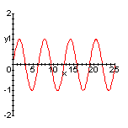
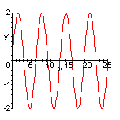
In the figure above (on the left) we see two waves. The bottom wave is one wavelength (λ) out of phase with the top wave. When the waves combine crests meet crests and valleys meet valleys. The resultant wave (on the right) has the same wavelength as the component wave but twice the amplitude. This is called constructive interference.
λ
=
+

It should be clear that the same resultant wave is obtained if the phase difference of the component waves is 2λ, 3λ, 4λ or any integer multiple of λ:

Phase difference for constructive interference = mλ (where m is an integer).
Rev. 1/23/08
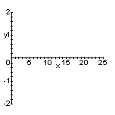
Now consider what happens when the waves are one-half wavelength out of phase.
=
+

In the figure above (on the left) we see two waves. The bottom wave is one-half wavelength (λ/2) out of phase with the top wave. When the waves combine crests meet valleys and valleys meet crests. The resultant wave (on the right) has zero amplitude. This is called total destructive interference.

It should be clear that the same resultant wave is obtained if the phase difference of the component waves is or any half odd integer multiple of λ:

Phase difference for total destructive interference = (where m is an integer).

Young’s Double Slit Experiment

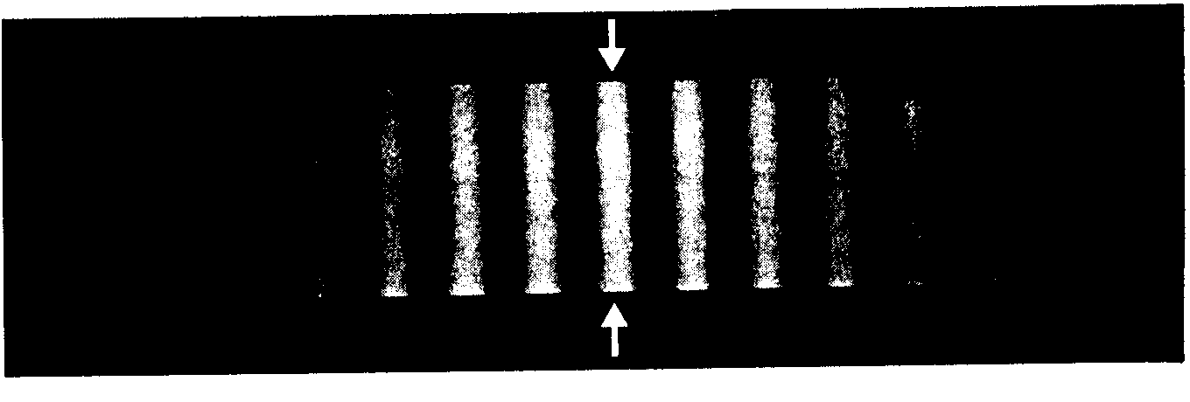The first wave theory of light was proposed by Christian Huygens (1629 – 1695). It was not until 1801, however, that the English scientist Thomas Young (1773 – 1829) performed an experiment that demonstrated the wave nature of light. In Young’s double slit experiment monochromatic light illuminates two slits in an opaque barrier. The slits are separated by a distance d. Light from the slits falls on a screen a distance D away. It is assumed that D >> d. The image that appears on the screen is a set of light and dark bands called interference fringes. The pattern the fringes form is called an interference pattern. The following figure shows a typical double-slit diffraction pattern. The arrows mark the central bright fringe, which is taken to be bright fringe 0.

We can use geometry to locate the bright and dark fringes of the double-slit diffraction pattern.
m
3

2

1

0

-1

-2

-3
Monochromatic light of wavelength λ.
θ
l₁
l₂
D
d
Screen

In the above figure a light ray from the top slit and a light ray from the bottom slit come together on the screen to form a bright fringe. The angle θ shown in the above diagram can be used to locate the fringe on the screen. We want to find a formula for θ in terms of the slit separation d, wavelength λ and fringe number m.

The distances l₁ and l₂ are distance the top ray travels to the screen and the distance the bottom ray travels to the screen, respectively. A small triangle has been drawn next to the slits in such a way that its base is the path length difference x = l₂ – l₁ of the light rays. If D >> d we may label this small triangle as follows:

We see that . For a bright fringe to appear on the screen, we must have constructive interference of the light waves at the point where the rays meet on the screen. According to the discussion on page 125 of these notes, we must have , where m is an integer. Hence
d
θ
x
Bright fringes of a double slit

Note that in the figure at the top of the page the rays locate the fringe corresponding to m = 2. The negative values of m locate bright fringes on the other side of the central bright fringe.
To locate the dark fringes in the double-slit diffraction pattern we only need note that total destructive interference of the light waves must occur at the point where the rays meet on the screen. In this case the path length difference of the rays has to be given by , where m is an integer. Hence
Dark fringes of a double slit

Example

Light of wavelength 550 nm is incident on a pair of slits separated by a distance of 0.12 mm. A screen is placed 2.0 m behind the slits. Find the distance y on the screen between the central bright fringe and the second dark fringe above it.

Caution. The dark fringes are labeled differently from the bright fringes. The first dark fringe from the central bright fringe corresponds to m = 0 in the above formula. The second dark fringe from the central bright fringe corresponds to m = 1 (not m = 2).

Since y << D,
y
D
θ

Thin-Film Interference

You have probably noticed that oil spots on the street show rainbow-like colors when viewed in daylight. This phenomenon is due to thin-film interference: light waves reflected from the street surface beneath the oil interfere with light rays reflected from the oil surface.

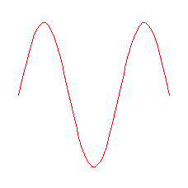
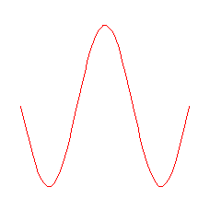
To understand thin-film interference we must first consider the phase relationship between light that is incident on a medium and light that is reflected from the medium.
n₁n₂
n₁ > n₂
n₁n₂
n₁ < n₂
In the figure on the left light is incident on the surface of a medium that has an index of refraction that is less than that of the incident medium. The reflected light has the same phase as the incident light. In the figure on the right light is incident on the surface of a medium that has an index of refraction that is greater than that of the incident medium. The reflected light does not have the same phase as the incident light; it is one-half wavelength out of phase with the incident light.

Now let us consider light rays that reflect from the surface of a thin film and the surface that is beneath the film.

In the figure above a monochromatic light ray in medium 1 is incident on the surface of medium 2. Part of the ray is refracted into the film and reflects at the bottom of the film from the surface of medium 3. This reflected ray emerges from the film as ray 2. Ray 1 is just that part of the incident ray that is reflected from the surface of medium 2. (Note that in the figure we assume n₁ < n₂.) Whether rays (1) and (2) interfere constructively or destructively depends on two things: i) their path length difference (which occurs entirely within the film) and ii) their phase relationship, which depends on the relative indices of refraction of the three media.
n₁
n₂
n₃
t
thin film
(1) (2)

Since the path length difference of the rays occurs entirely within the thin film, we need the wavelength of the light in the film. Let f be the frequency of the light and v_{film} be the speed of light in the film. Then

where n is the index of refraction of the film.

Let us now consider the following example.

Example

Crown glass in a camera lens is to be made “nonreflecting” by coating it with magnesium flouride (MgF₂) that has index of refraction 1.38. This coating is to prevent light of wavelength 550 nm from reflecting from the lens. Find the minimum nonzero thickness of the coating that is required.

From the table on page 782 of your text, Since n₁ < n₂ and n₂ < n₃ there is a half wavelength phase change for the ray reflected at the coating surface and the ray reflected at the glass surface. Hence the only possible phase difference in the reflected rays will be due to the path length difference, the distance the second ray travels in the coating. We will get destructive interference if this path length difference is , where λ is the wavelength of the light in the coating. For the minimum coating thickness we set . (2t because the light ray in the film traverses it twice – once going down and again going up.)

Remarks. The human eye is most sensative to light with wavelength 550 nm in air. This light is in the green part of the visible spectrum. (Can you give an explanation as to why the human eye is most sensative to green light?) Precision lenses (used in the more expensive cameras) are coated to prevent the loss of light by reflection. These lenses, when viewed in ordinary light, appear to have a purple or bluish tint. Why is this?

Example

A sheet of crystalline quartz 395 nm thick is suspended in air. Light of wavelength 610 nm is incident nearly perpendicularly on the surface of the quartz. Is there constructive or destructive interference when this light is reflected from the quartz surfaces?

First calculate the wavelength of the light in quartz.

Since the thickness of the sheet equals the wavelength of the light in quartz, the path length difference between the ray that reflects from the quartz surface and the ray that reflects from the air surface at the back of the quartz is 2λ. A path length difference equal to an integer number of wavelengths is equivalent to a zero phase difference. However, we must now take into account phase changes due to reflections. There is a phase change in ray (1) of one-half wavelength at the air-quartz boundary since n₁ < n₂. But there is no phase change in ray(2) at the quartz-air boundary because n₂ > n₃ (n₃ = 1.00, the index of refraction of air). Hence there is an overall phase difference of one-half wavelength between rays (1) and (2) when they emerge from the quartz. This causes total destructive interference of this wavelength.

Diffraction

Diffraction is the bending of waves around obstacles or the edges of an opening. Diffraction is an interference effect; the degree of the effect (the amount of bending of the wave) depends upon the relative size of the object encountered with the wavelength of the wave. For example, if someone is talking around a corner in the hall you can hear the person but you cannot see the person. The reason you can hear the person is that sound diffracts greatly around the corner because the wavelength of sound (a fraction of a meter) has dimensions comparable to those of the hallway. The reason you cannot see the person is that light diffracts very little around the corner. This is because the wavelength of light (a few hundred nanometers) is much smaller than the dimensions of the hallway.

Christian Huygens, who proposed the first wave theory of light, developed a principle that is useful in explaining why diffraction occurs. This is called Huygens’ principle:

Every point on a wave front acts as a source of tiny wavelets that move forward with the same speed as the wave; the wave front at a later instant is the surface that is tangent to the wavelets.
For example, Huygens’ principle can be used to explain the shape of a water wave in a river as it passes near the shore. The speed of the water wave depends on the water depth; the deeper the water the faster the wave. As a water wave passes near the shore, the water depth changes rapidly, thereby distorting the wave.
deep
shallow
wavefront
Huygens’ wavelets

New wavefront

Single-Slit Diffraction

Consider a monochromatic light wave with wavelength λ incident on a slit of width W as shown below. (The size of the slit is greatly exaggerated.)
W
x
screen
θ

A dashed line is drawn at the center of the slit, dividing it in half. Consider two parallel rays, one from the top half of the slit and the other from the bottom half of the slit. The distance x in the figure is the path length difference of the two rays. A converging lens focuses the two rays onto a distant screen. (The size of the lens is exaggerated; we assume that a thin lens is used and that each ray travels the same distance through the glass.) The small triangle drawn next to the slit may be labeled as follows:
x
θ
The single-slit diffraction pattern consists of a broad bright band in the center with alternating dark and bright fringes on either side. The center of the broad bright band lies at a point on the screen that is directly across from the slit. What we want to do is locate the dark fringes by finding the angle θ the line drawn from the slit to a dark fringe makes with respect the line drawn from the slit to the broad bright band. See Figures 27.21 and 27.22 on pages 867 and 868 of your text.
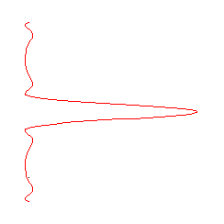
θ
First dark fringe.
Central bright band.
Intensity

To locate the first dark fringe we set the path length difference x equal to λ/2.
This formula gives the angle for the first dark fringe in the single slit diffraction pattern.

To locate the second dark fringe we divide the slit into four regions.
W
x
θ
a
b

Once again x is the path length difference between the two rays. The small triangle drawn next to the slit is now labeled as follows:

x
θ

For destructive interference we once again set x = λ/2:

This formula gives the angle for the second dark fringe in the single slit diffraction pattern.

Question: How do the two rays from the regions labeled a and b interfere, if they are parallel to the rays just discussed? Why?
By continuing the above analysis we find a general formula for the dark fringes of the single-slit diffraction pattern:
Dark fringes for single-slit diffraction

The positive values of m locate the centers of the dark fringes on one side of the central bright maximum; the negative values locate the centers of dark fringes on the other side.

Example

A slit of width W is illuminated with red light of wavelength 650 nm. For what value of W will the first dark fringe for the red light be at θ = 15°?

For the incident light to flare out by as much as +15° the slit has to be very fine. Note that a fine human hair may be about 100 μm in diameter. Because the wavelength of light is so small when compared to everyday objects, the diffraction of light is difficult (but not impossible) to observe. This is why ray optics works so well in the applications of optics, such as the manufacture of lenses for glasses, binoculars and telescopes.

