Equipotential Surfaces and Capacitors

Definition An equipotential surface is a locus of points that are all at the same electric potential.

Thus an equipotential surface is a surface on which the electric potential is the same everywhere. The equipotential surfaces surrounding an isolated point charge are concentric spheres. See the figure below.
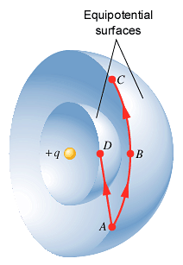
r
Taking the electric potential to be zero at infinity, the electric potential at point D in the figure is . The electric potential at point B is lower than that at point D because point B is farther away from the charge q.

If a small positive test charge q₀ moves along the outer equipotential surface along the path from A to B the work W_{AB} done by the electric field is given by Equation 19.4:

V_{B} – V_{A} = –W_{AB}/q₀

But V_{B} = V_{A} so that W_{AB} = 0 and the electric field does no work on the test charge. This is possible only if the electric force acts in a direction that is perpendicular to the displacement of the test charge. (Remember the formula for work from Physics 111: W = Fscos(θ), where θ is the angle between the force F and the displacement s. If θ = 90° then W = 0 J.)

We conclude that the electric field lines intersect an equipotential surface at right angles. Note that the electric field lines are directed from high electric potential to low electric potential.
E
E

Question: In the figure at the right, which of the three equipotential surfaces shown is at the highest electric potential? Which is at the lowest?

There is a quantitative relationship between the electric field and equipotential surfaces. Consider a region of space where there is a uniform electric field directed from left to right. (Such a region exists, for example, near the center of a parallel-plate capacitor. See the figure below.) In this region the equipotential surfaces are parallel vertical planes.
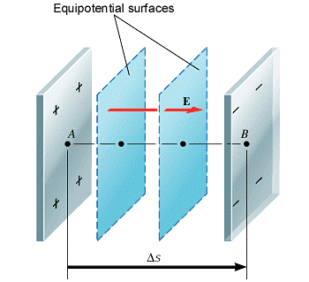

If a small positive test charge q₀ moves from point A to point B the work done on the charge by the electric field is given by

W_{AB} = FΔs

Where F is the magnitude of the electric force on q₀:

F = q₀E
Thus
W_{AB} = q₀EΔs

But from Equation 19.4 V_{B} – V_{A} = –W_{AB}/q₀ so that

V_{B} – V_{A} = − EΔs
or
E = −ΔV/Δs

where ΔV = V_{B} – V_{A}. The quantity ΔV/Δs is referred to as the potential gradient and has units of volts per meter.

Remarks. The potential gradient is a vector field that points in the direction of the most rapid rate of increase of the potential. Because of the negative sign in the above formula we see that the electric field points in the direction of the most rapid rate of decrease of the potential. (Proofs of these statements are beyond the scope of this course. However, interested students may refer to a suitable calculus text such as Anton’s Calculus.)

Remark. Because of the above formula we see that alternate units for the electric field are volts per meter: V/m.
Exercise: Show that 1 V/m = 1 N/C.

Example

The plates of a parallel plate air capacitor are connected to the terminals of a 5.0 volt battery. The plates are separated by a distance of 3.0 mm. Neglect fringing effects.

- Find the magnitude of the electric field between the plates.
- Find the surface charge density that must exist on each plate.

a.

b.

Capacitance of a Capacitor

A capacitor consists of two conductors placed next to one another. The conductors can be of any shape, but they must not make contact. (We will refer to the two conductors as “plates” since the simplest capacitor consists of two parallel conducting plates placed next to one another. In general, however, these conductors can have any shape.) To help keep the plates apart (and for other reasons that will be discussed shortly) an insulating material called a dielectric is placed between the plates. If just air is between the plates the capacitor is called an air capacitor.

A capacitor is a device for storing electric charge. If the one plate of a capacitor is connected to the positive terminal of a battery and the other plate connected to the negative terminal of the same battery some of the electrons on the first plate are transferred to the second plate by the battery, leaving a net amount of positive charge on the first plate and an equal amount of negative charge on the second plate. When the battery is removed the positive charge on the first plate is attracted to the negative charge on the second plate (and vice versa) and the positive and negative charges remain “stored” in the capacitor. (Note that as a whole, however, the capacitor remains electrically neutral.)
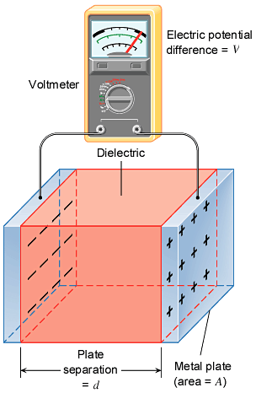

Not all capacitors have the same capacity for storing charge. This capacity depends on the area of the plates, their separation and kind of dielectric that is placed between them. Let q be the magnitude of the charge on either plate of a charged capacitor and let V be the potential difference between the plate with the positive charge and the plate with the negative charge. (See the figure at the right.) The ratio

C = q/V

is called the capacitance of the capacitor and is a measure of the ability of the capacitor to store electric charge. The units of capacitance are coulombs/ volt (C/V). 1 C/V = 1 farad (F) named in honor of the English physicist Michael Faraday (1791–1867) who originated the concept of electric field lines.

If one knows the potential difference V between the plates of a capacitor with capacitance C, the magnitude of the charge on either plate q can be found:

q = CV.

The farad is a large unit of capacitance. Typical capacitors have capacitances that are measured in microfarads (μF, 10⁻⁶ F) or picofarads (pF, 10⁻¹² F).

The Dielectric Constant
When a dielectric is placed between the plates of a capacitor a negative charge is induced on the surface of the dielectric next to the positive plate and a positive charge is induced on the surface of the dielectric next to the negative plate. For this reason the electric field E inside the dielectric is smaller than the electric field E₀ that would exist between the plates of the capacitor if the dielectric were not present.

dielectric
The dielectric constant of the dielectric can be defined as the ratio

κ = E₀/E.

Since E₀ > E the dielectric constant κ is a number greater than unity. See Table 19-1 in your text for dielectric constants of some common substances.

TABLE 19.1 Dielectric Constants of Some Common Substancesª
Substance | Dielectric Constant, k
Vacuum | 1
Air | 1.00054
Teflon | 2.1
Benzene | 2.28
Paper (royal gray) | 3.3
Ruby mica | 5.4
Neoprene rubber | 6.7
Methyl alcohol | 33.6
Water | 80.4

The Capacitance of a Parallel Plate Capacitor

Recall from the previous example that the magnitude of the electric field between the plates of a parallel plate capacitor can be calculated from

Now E = E₀/κ and E₀ = σ/ε_{0,} where σ is the surface charge density on either plate: σ = q/A where A is the surface area of each plate. Thus

A comparison of the last equation with q = CV shows that for a parallel plate capacitor

Note that from last formula above we see that ε₀ can be expressed in the units F/m. (Why?)
Example

Suppose an air capacitor consisted of two identical square copper plates placed side by side with a plate separation of 1.0 cm. Find the cross-sectional area of each plate if the capacitance of the capacitor is to be 1.0 F.

Each of these plates would have a side over 33 km long! This example illustrates that, typically, common capacitors that you hold in your hand have capacitances that are only small fractions of a farad.

Effect of a Dielectric on Capacitance

From the previous example we saw that if just air is between the plates of a parallel plate capacitor the capacitance is . When a dielectric with dielectric constant κ is placed between the plates the capacitance becomes . We can conclude that, for the parallel plate capacitor,

It can, in fact, be shown that this formula is valid for all capacitors, regardless of their shape. So the insertion of a dielectric between the plates of a capacitor has the effect of increasing the capacitance of the capacitor.

Remark. The use of a dielectric to increase capacitance has a drawback. When a dielectric is subjected to an electric field that is strong enough the dielectric breaks down and becomes a conductor. The minimum electric field strength to which a dielectric can be subjected without breakdown is called the dielectric strength of the dielectric. The dielectric strength of air, for example, is 3 × 10⁶ V/m; for paper it is 16 × 10⁶ V/m. Placing a dielectric between the plates of a capacitor, while increasing the capacitance, also limits the potential difference that can be placed across the plates of the capacitor. If too high a potential difference is placed across the capacitor’s plates the dielectric strength of the dielectric between the plates can be exceeded causing the capacitor to break down and become useless.

Synthetic dielectrics have been developed that have enormous dielectric constants. A demonstration will be given in class of capacitor with a cross-sectional area about the size of a quarter that has a capacitance of 1.0 F.

Example

- Estimate the capacitance of a capacitor made from two quarters with a piece of notebook paper placed between them.
- What would the dielectric constant of the material placed between the quarters have to be to produce a capacitance of 1.00 F? (Assume the same separation of the quarters.)
a.

b.

Energy Stored in a Capacitor

From the definition of electric potential the work required to move a charge q through a potential difference ΔV is given by W = qΔV. Hence the work required to place a charge q on a capacitor is where is the average potential difference between the plates. Here where V is the potential difference between the plates after charge q is transferred. Since q = CV

Where E denotes the energy stored in the capacitor as result of the work W that was done to charge the capacitor. (E = W.) Thus, in addition to storing charge, a capacitor also stores energy.

Example

Estimate the potential difference between the plates of the 1.00 F capacitor after the capacitor is charged by 5.00 turns of the hand-held generator attached to it. Assume that the generator’s handle is 5.00 cm long and that a force of constant magnitude 1.00 N is applied tangent to the circular path the end of the handle takes as it is turned. Neglect any work done against friction.

