Chapter 24 Electromagnetic Waves

Rev. 1/23/08

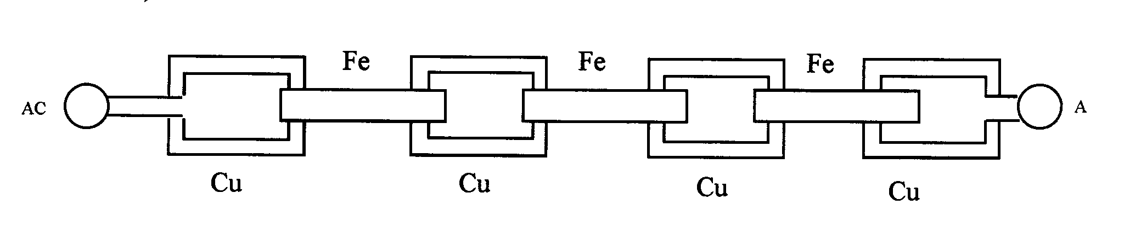 Consider a chain made of copper and iron links so that every link of iron is adjacent to a link of copper (and vice versa).
Connect an AC source to the leftmost copper link and an AC ammeter to the rightmost copper link. Assume that the links do not make physical contact.

The oscillating electric current in the leftmost copper link induces an oscillating magnetic field in the adjacent iron link to its right. This oscillating magnetic field in turn induces an oscillating current in the next copper link to the right, and so on. The AC ammeter on the far right registers an oscillating current in the rightmost copper link due to the oscillating current in the leftmost copper link despite the fact that there is no physical connection between the two.
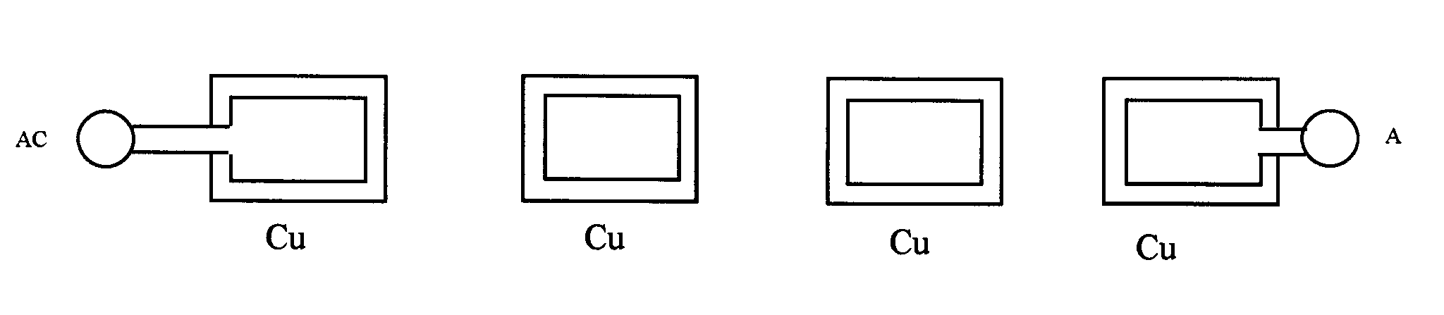
Now suppose that we remove the iron links:

An oscillating magnetic flux still links all the copper links and an electric current is still induced in the three copper links on the right, causing the AC ammeter on the far right to register an oscillating current.
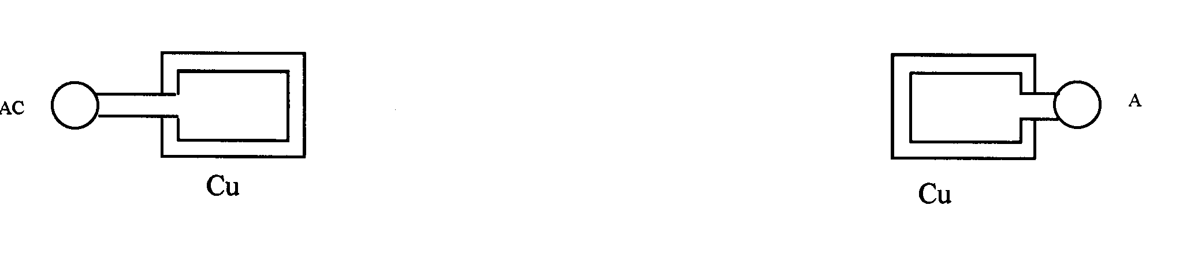
Now suppose that we remove the two copper links in the center:

As we saw before, an electric field is induced in the region of a changing magnetic field even if no physical conductor is present to carry a current:

The AC ammeter on the far right still registers an oscillating current, even if there is no matter present between the leftmost and rightmost conducting links!
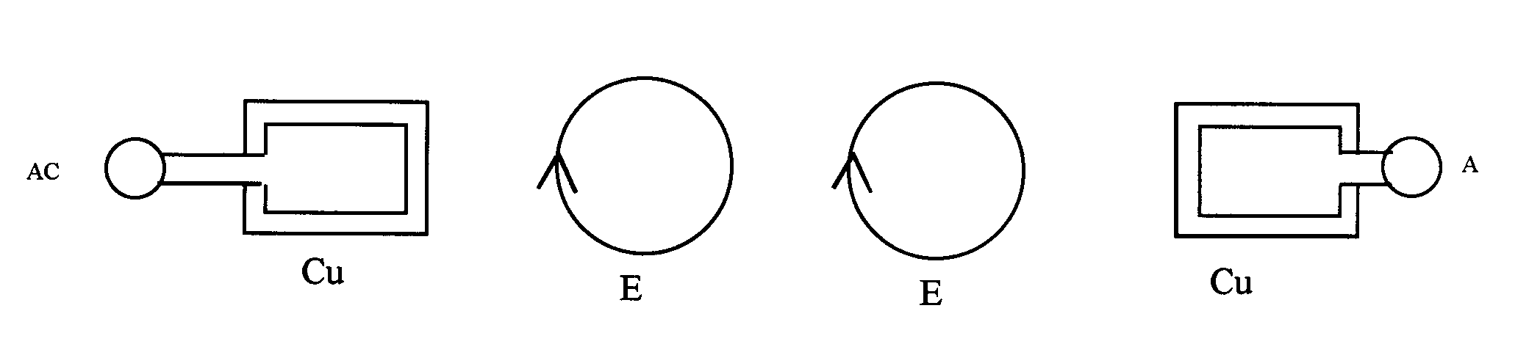
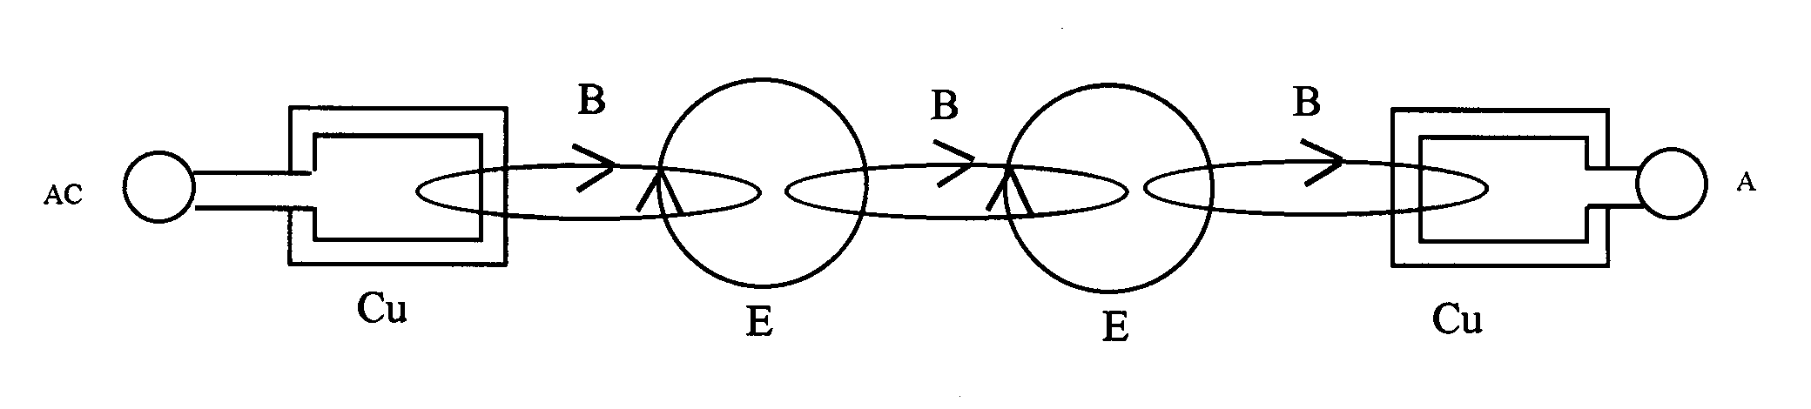 Now let us add the magnetic field lines (shown in perspective) to the above drawing:
Note how the planes of the electric and magnetic field lines in the space between the copper links make right angles with one another.

Now suppose that the AC source on the far left is off. We now turn it on. The electric and magnetic field lines in the space between the copper links do not appear at the same instant we turn on the AC source. First the leftmost oscillating magnetic field appears, then the leftmost oscillating electric field appears, then the oscillating magnetic field in the middle appears, then the next oscillating electric field on the right appears and so on. The oscillating electric and magnetic field lines advance to the right, forming an electromagnetic wave in space. The advancing wavefront moves at the speed of light: 3 x 10⁸ m/s. This wavefront spreads out in many different directions from the copper link on the left, so that if we take the copper link on the right (still connected to the AC ammeter) and shift it up, down, in or out of the diagram the ammeter still registers an oscillating current. (See the drawings in The Restless Universe by Max Born¹.)

Maxwell showed his equations for electricity and magnetism predict the existence of electromagnetic waves and that the speed with which these waves move is the speed of light. Maxwell concluded that visible light, along with the other radiations known at the time, infrared and ultraviolet radiation, are electromagnetic waves. Spurred on by these results, the German physicist Heinrich Hertz later discovered what we now call radio waves and verified that they move through the laboratory at the same speed as visible light.

We now know that electromagnetic radiation has a very wide spectrum, consisting of waves with wavelengths as small as 10⁻¹⁶ m and as large as 10⁸ m (and larger). Visible light occupies only a very small portion of this spectrum, with wavelengths in air from 400 nm (violet light) to 700 nm (red light). Recall from Physics 111 that the frequency, wavelength and speed of a wave are related by

fλ = c

so that the frequency of an electromagnetic wave is given by

f = c/λ.

where c is the speed of light in the medium through which it is traveling. As we shall see in Experiment LO-2, the speed of light in transparent matter is less than it is in free space or air. It is the frequency of light that determines its color. (Recall that the frequency of sound determines its pitch.) The frequency of red light is lower than the frequency of violet light.

Ex. Calculate the frequency of red light with wavelength 700 nm and the frequency of violet light with wavelength 400 nm.

These answers can also be written as where 1 THz = 1 terahertz = 10¹² Hz.

An electromagnetic wave, like any periodic wave, has a frequency f and a wavelength λ that are related to the speed v of the wave by v = fλ, Equation 16.1 in the text. Visible light consists of electromagnetic waves, so the speed at which electromagnetic waves move is called the speed of light. The speed of light depends upon the medium (water, glass, air, etc.) the electromagnetic waves are traveling in. The speed of light in a vacuum is a universal constant (like the mass of an electron or the gravitational constant G). The speed of light in a vacuum is denoted by c; its value is

Electromagnetic Plane Waves

Electromagnetic waves, like water waves, can spread out in many different patterns. A wavefront is the geometrical figure formed by the locus of points on a specified part of the wave, such as a wave peak. For example, the wavefronts of the water waves that appear on the surface of a pond after a pebble is dropped into the pond are circles.

As we saw above, an electromagnetic wave consists of electric and magnetic fields oscillating in phase at right angles to one another. The velocity of the wave makes a right angle with the electric and magnetic fields. For this reason electromagnetic waves are called transverse waves. The direction of motion of an electromagnetic wave may be determined by a right-hand rule: Extend the fingers of your right hand so that they point in the direction of the electric field in the wave. Rotate your right hand until the magnetic field points out of the palm. The thumb of your right hand now points in the direction of travel of the wave.

In an electromagnetic plane wave the wavefronts are planes in space. The wave advances in a direction perpendicular to these planes. See the figure on the next page.

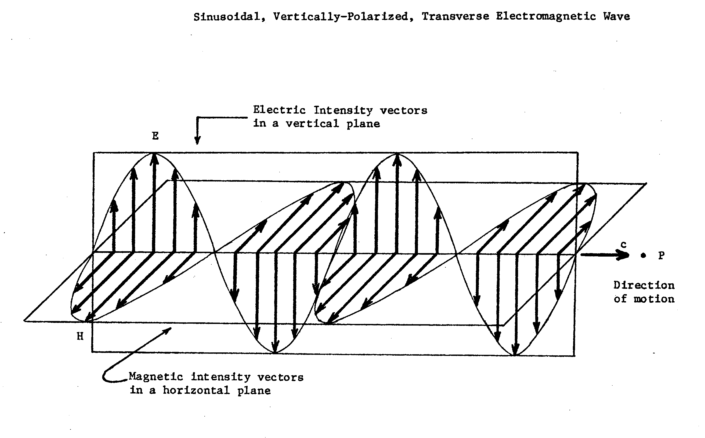
The wavefront moves with speed c in the direction of motion of the wave.

The Electromagnetic Spectrum

Electromagnetic waves exist with an enormous range of frequencies, from values less than 10⁴ Hz to greater than 10²² Hz. The collection of all these waves is called the electromagnetic spectrum.

Type of Wave Frequency Range (Hz) Wavelength Range

Radio waves 10⁴ - 10¹² 10⁴ – 10⁻⁴ m

Infrared 10¹² - 10¹⁴ 10⁻⁴ – 10⁻⁶

Visible 700 – 400 nm

(red, orange, yellow, green, blue, violet)

Ultra-violet 10¹⁴ - 10¹⁷ 10⁻⁷ – 10⁻⁸ m

X-rays 10¹⁷ - 10²⁰ 10⁻⁸ – 10⁻¹² m

Gamma rays 10²⁰ - ? 10⁻¹² - ? m

The Speed of Light

Maxwell showed that his four equations of electromagnetism predict the existence of electromagnetic waves; they also predict the speed of these waves to be

where If one substitutes the measured values of ε₀ and μ₀ one obtains the correct value of the speed of light in a vacuum. This is a remarkable result, since ε₀ and μ₀ were unrelated to wave phenomena: ε₀ is a constant in Coulomb’s law and serves as a measure of the relative strength of the electrostatic force in a vacuum. Similarly, μ₀ is a constant that appears in Ampere’s law and serves as a measure of the relative strength of the magnetic force in a vacuum. The fact that Maxwell was able to bring these two fundamental constants together to correctly predict an aspect of what appeared to be a completely unrelated phenomenon (the speed of light) was a great triumph for Maxwell’s theory and classical physics. For not only do Maxwell’s four equations describe all electromagnetic phenomena, they contain all the laws of optics as well! We will study some of the laws of optics in the chapters that follow.

The fact that light travels at a finite speed means that there is time lapse between when light leaves an object and when it strikes the retina of a person’s eye. What the person sees is the object as it was a short time ago, not the way it is when the light strikes the retina. Because of the enormous speed of light, this time lapse is not large enough to have a significant effect in our daily lives when we deal with nearby objects. However, when one views astronomical objects (either with an unaided eye or a telescope), one sees the objects as they were in the past. How far in the past depends on the distance of the astronomical object.

Examples

The mean earth - moon distance is . How far back in time is the image of the moon when viewed from earth?

The mean earth - sun distance is . How far back in time is the image of the sun when viewed from earth?

Astronomical instruments such as the Hubble space telescope can image objects at enormous distances. A light-year is the distance light travels in one year (in a vacuum). Hubble has taken pictures of objects billions of light years away. Because of the time lapse between the instant the light left those objects and the instant the light arrived on earth, those pictures show those objects as they were in the past, several billion years ago!
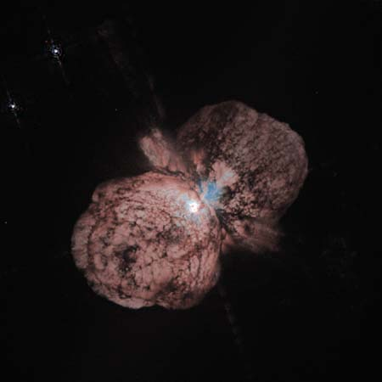

June 10, 1996
Photo No.: STScI-PRC96-23a
A huge, billowing pair of gas and dust clouds is captured in this stunning NASA Hubble Space Telescope image of the supermassive star Eta Carinae.
Using a combination of image processing techniques (dithering, subsampling and deconvolution), astronomers created one of the highest resolution images of an extended object ever produced by Hubble Space Telescope. The resulting picture reveals astonishing detail.
Even though Eta Carinae is more than 8,000 light-years away, structures only 10 billion miles across (about the diameter of our solar system) can be distinguished. Dust lanes, tiny condensations, and strange radial streaks all appear with unprecedented clarity.

The event observed in this Hubble photograph occurred 8,000 years ago.

Energy Carried by Electromagnetic Waves

All traveling waves transport energy from one location to another. The energy density (energy per unit volume) of an electromagnetic wave can be found from the formulas for the energy densities of the electric and magnetic fields that comprise the wave:

Electric Energy Density: .

Magnetic Energy Density: .

Total energy density:

It can be shown that for an electromagnetic wave propagating through the vacuum or air the electric and magnetic field amplitudes are related by

If we square both sides of the equation we get

The expression on the left is the energy density of the electric field; the expression on the right is the energy density of the magnetic field. These two energy densities are equal in an electromagnetic wave.

The total energy density can then be expressed as either

Example

The rms electric field striking the top of earth’s atmosphere is . Find the average total energy density of the electromagnetic wave.

Intensity

Suppose that a portion of a wave passes through a rectangular area (such as a window) in a direction perpendicular to the area. Since a wave carries energy, some of the wave’s energy has passed through the area. Since the wave travels with a finite speed, it will take some time (call it t) for this energy E to pass through. If the rectangular region has area A the intensity of the wave is defined as

If the wave is a light wave traveling in air, the distance the wave travels in time t is ct; the volume that it sweeps
out as it passes through the area A is Act. Since the energy density of the wave is u, we have E = uAct and

.

Using the formulas for energy density this can be written as

Example

A photocell calculator needs 20 mW to run. What is the minimum rms electric field of the light required to operate the calculator if the area of the photocell is 3.0 cm²?

Remark. The vector that has magnitude S and direction the same as the wave’s velocity is called the Poynting vector, named after John Henry Poynting (b. Sept. 9, 1852, Monton, Lancashire, Eng.--d. March 30, 1914, Birmingham, Warwickshire), the British physicist who introduced the concept. The Poynting vector, important in advanced electromagnetic theory, is not only related to the rate of energy transfer of the wave but also to the rate of momentum transfer of the wave.

Doppler Effect

The Doppler effect is familiar to most people as the change of pitch of a sound source due to its motion away from or towards an observer. The pitch of a sound is determined by the frequency of a sound wave; the frequency of a moving sound source is different from its frequency when it is at rest.

There is also a Doppler effect for light waves. The frequency of a moving light source is different from its frequency when it is at rest. The Doppler effect requires a source and an observer. For simplicity assume that
the source moves either directly toward or directly away from the observer and that the relative speed of the source and observer is u.

Let f be the frequency of the source and be the frequency measured by the observer. The correct derivation of the Doppler effect formula (if one wants a formula for 0 < u < c) requires use of the Special Theory of Relativity. The result is

where u > 0 if the source and observer are separating and u < 0 if the source and observer are approaching one another. This formula is correct for all speeds. Note that u is the relative speed of the source and the observer. It does not matter if the source is stationary and the observer is moving or if the observer is stationary and the source is moving or if both are moving. If u is their relative speed the above formula is correct. This formula is called the relativistic Doppler effect formula.

If the relativistic Doppler effect formula simplifies to

where the + sign is used if the source and observer are approaching one another and the – sign is used if the source and observer are moving away from one another.

Example

Atomic hydrogen, when heated, gives off a set of visible wavelengths called the Balmer series. (The Balmer series is an example of an atomic spectrum.) The red line in this series has wavelength λ = 656 nm. Find the wavelength of this line (as observed on earth) if the hydrogen atom that emits it is in a galaxy that is moving away from earth with speed 0.64c.

We see that the wavelength of the source is longer when it is moving away. This effect is known as the Doppler red shift or simply the red shift. What kind of “shift” would we see if the source were moving towards us?

The discovery of the red shift of distance galaxies was instrumental in forming present models of the universe. Edwin Hubble (American astronomer b. Nov. 20, 1889, Marshfield, Mo., U.S.--d. Sept. 28, 1953, San Marino, Calif.) discovered that the farther a distant galaxy is from earth, the greater is the red shift of the light coming from the galaxy. Hubble interpreted these red shifts as Doppler shifts, and found a remarkable relationship: the speed of recession of a galaxy from earth is directly proportional to its distance from earth. This discovery is the origin of the theory of the expanding universe.

Polarization

Most natural light consists of electric field vectors vibrating in many different directions. Such light is called unpolarized. A light wave that consists of electric field vectors all vibrating along the same line is called linearly polarized. A device that produces polarized light from unpolarized light is called a polarizer.

Polarizer and Analyzer

Suppose that unpolarized light is sent through a sheet of polarizing material (the polarizer)so that the light that emerges is polarized and has average intensity . (The intensityis always half the intensity of the unpolarized light that enters the polarizer.) Suppose the light then passes through a second sheet of polarizing material. This second sheet is called the analyzer. If the polarizing direction of the analyzer makes an angle θ with the polarizing direction of the polarizer then the average intensity of the light passing through the analyzer is given by

.

This result is known as Malus’ law after the French engineer Etienne-Louis Malus (1775 – 1812) who discovered it.

Remark. If θ = 90° the polarizer and analyzer are said to be crossed. How much light emerges from such crossed polarizers? Why?

Example

Light with average intensity enters a polarizer-analyzer pair. The light that emerges from the analyzer has intensity . What angle does the analyzer’s polarizing direction make with that of the polarizer?

Warning It is incorrect to write because the polarizer reduces the initial intensity by ½. Taking this into account we write

