Alternating Current

Alternating current is produced in a circuit when the potential difference (which we call voltage) between the terminals of the seat of emf in the circuit changes sign from moment to moment. The most common such seat of emf is called an AC generator. The voltage V between its terminals is given by

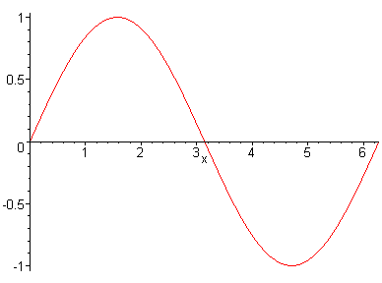
where V₀ is the magnitude of the maximum voltage (the voltage amplitude), f is the frequency (in cycles per second) and t is the time in seconds. As we shall see, such a voltage is very easily produced by a rotating armature.
V
t
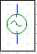

Symbol for an AC generator:

The voltage V produced between the terminals of an AC generator fluctuates sinusoidally with time.

If an AC generator is placed across a resistor R the current in the circuit is given by

Power in an AC Circuit

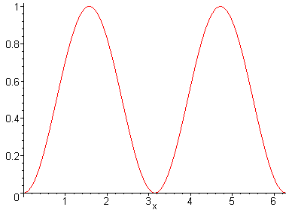
Using we get for power: . Since the power also fluctuates with time, it is convenient to measure the average power over one cycle. This is obtained from the average value of over one cycle: ½.
½
y
t
Thus we can write where denotes average power over one cycle. Since we can also write is the root mean square voltage. The root mean square (or rms) value is a way of expressing an average value of the magnitude of a quantity that varies sinusoidally with time over one cycle. Since the current in an AC circuit also varies sinusoidally with time we can also write where I₀ is the current amplitude. Hence we can also write .

Note the difference between average power and peak power:

.

(We assume that power is being delivered to a resistive load.)

Example

A light bulb consumes 60 watts of power when connected to 120 vac.

a. What is the resistance of the light bulb?

b. What current does the light bulb draw?

Current refers to rms current:

c. What is the peak power consumed by the light bulb?

