Supplementary Problems for PHYS 241
Test 3

1. A copper cylinder has radius 2.0 cm and length 5.0 cm. The initial temperature of the cylinder is 25°C. Look up the resistivity and the temperature coefficient of resistivity of copper.

a. Wires are connected to the cylinder as shown in Figure 1. What is the
Figure 1
electrical resistance of the cylinder between the wires?

b. If a current of 2.0 A passes through the wires, at what rate is electrical
energy dissipated by the cylinder?

c. What would the resistance of the copper cylinder be if its temperature
rises 100 C°?

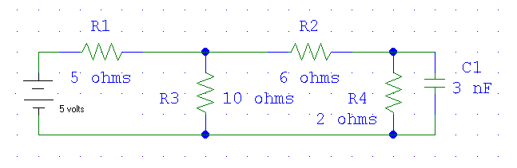2. Consider the schematic shown in Figure 2. Assume two
significant figures for all data.

a. Find the loop current I₁ in the loop on the left and the
loop current I₂ in the loop in the middle.

b. Find the potential drop across the 10 ohm resistor. State which side of the resistor is at the higher potential.
Figure 2

c. Find the charge on the capacitor.

3. An initially uncharged capacitor of capacitance 3.30 μF is placed across the terminals of a battery with emf
6.20 V. The battery has an internal resistance of 0.200 ohm.

a. Find the formula for the current drawn from the battery as a function of time. What is the time constant of
this circuit?

b. Use calculus and your answer to part a to find the total charge drawn from the battery.

c. Show that your answer to part b is just the final charge of the capacitor (so that charge is conserved).
Answers to Supplementary Problems for PHYS 241
Test 3

1. a. 0.67 μΩ

b. 2.7 μW

c. 0.96 μΩ

- a. I₁ = 0.53 A clockwise, I₂ = 0.29 A clockwise.

b. 2.4 V; the top of the resistor is at the higher potential.

c. 2.9 nC

- a. ; τ = 6.60 × 10 ^{– 7} s

b.

c. (the same as the answer to part b, allowing for round-off error)

