Charging by Induction

A plastic rod is rubbed with fur, giving the plastic a negative charge. When the rod is brought near an electroscope the leaf of the electroscope rises. We say that the electroscope acquires an induced charge. When the rod is removed the leaf returns to its normal vertical position.

Suppose the experiment is repeated. But while the rod is held near the electroscope (without touching it) the electroscope is “grounded” by someone placing a finger on the electrode.

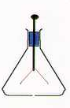
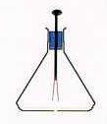
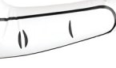

Positive charge from the finger is attracted to the rod. This positive charge enters the electroscope and neutralizes the induced charge on the leaf. If the finger is removed with the rod in place the leaf remains in its vertical position. But if the rod is also removed the leaf rises again.

+

When the positive charge entered the electroscope through the finger it gave the electroscope a net positive charge. This excess positive charge is not evident at first, when the negatively-charged rod is nearby. This is because this excess charge is held at the top of the electroscope because of its attraction to the rod. When the rod is removed the excess charge redistributes itself on the electroscope and the leaf rises. Note that the electroscope acquired a charge opposite in sign to that on the rod.

This process is called charging by induction. What would happen if a positively-charged rod were used?

Note: In reality, positive charge does not move through matter, only negative charge does. What we interpret as positive charge moving in one direction is actually negative charge moving in the opposite direction. However, for many applications, such as charging by induction, this distinction does not matter.

